**COVID-19 Dataset Analysis**

**Project Overview**

This project analyses COVID-19 data using Excel and Power BI to track confirmed cases, recoveries, fatalities, and vaccination rates across regions. It includes data cleaning, trend analysis, interactive dashboards, and visualizations to identify patterns and insights. Key metrics such as infection rates, vaccination progress, and country-wise comparisons aid in decision-making and reporting.

**Dataset Description:**

**Datasets:**

* COVID-19 Dataset (Excel)

**Key Features:**

**Key metrics include:**

* Total Confirmed Cases
* Total Deaths
* Total Recoveries
* Vaccination Rates
* Case Fatality Rate (CFR)
* Infection Growth Trends

**Data Cleaning Process:**

**To ensure data quality, several cleaning steps were performed:**

* Excel Cleaning: Organized raw data for better readability.
* Power BI Power Query Cleaning: Applied advanced cleaning and transformation techniques.
* Handled Missing Values: Replaced or removed missing data to ensure consistency.
* Removed Blank Rows and Duplicates: Eliminated unnecessary rows and duplicate entries.
* Changed Correct Data Format & Data Types: Standardized data formats and types for accuracy.
* Transformed the Data Table: Restructured data tables for better analysis and visualization.

**Descriptive Statistical Analysis**

**Basic descriptive statistics were used to summarize and understand the data, including:**

* Mean, median, and mode for key indicators.
* Distribution analysis for infection rates, recoveries, and fatalities.
* Identification of trends and outliers over time.

**DAX Calculations**

**Custom DAX calculations were applied in Power BI for:**

1. Average Infection Rate - Calculates the average infection rate across countries.
2. Case Fatality Rate (CFR) (%) - Computes the average case fatality rate in percentage.
3. Total Cases by Region - Aggregates the total confirmed cases across regions.
4. Yearly Infection Growth Rate - Computes the infection growth rate for each year.
5. Mean Recovery Rate - Determines the average recovery rate across countries.
6. Median Recovery Rate - Returns the middle recovery rate value when sorted.
7. Mode of Confirmed Cases - Identifies the most frequently occurring case count.
8. Vaccination Rate (%) - Calculates the average vaccination rate in percentage.
9. Standard Deviation of Cases - Measures the spread of case numbers from the mean.
10. Total Deaths by Region - Summarizes the total death count by region.
11. Yearly Death Toll Calculation - Computes the total death count for each year.

**Dashboard Description:**

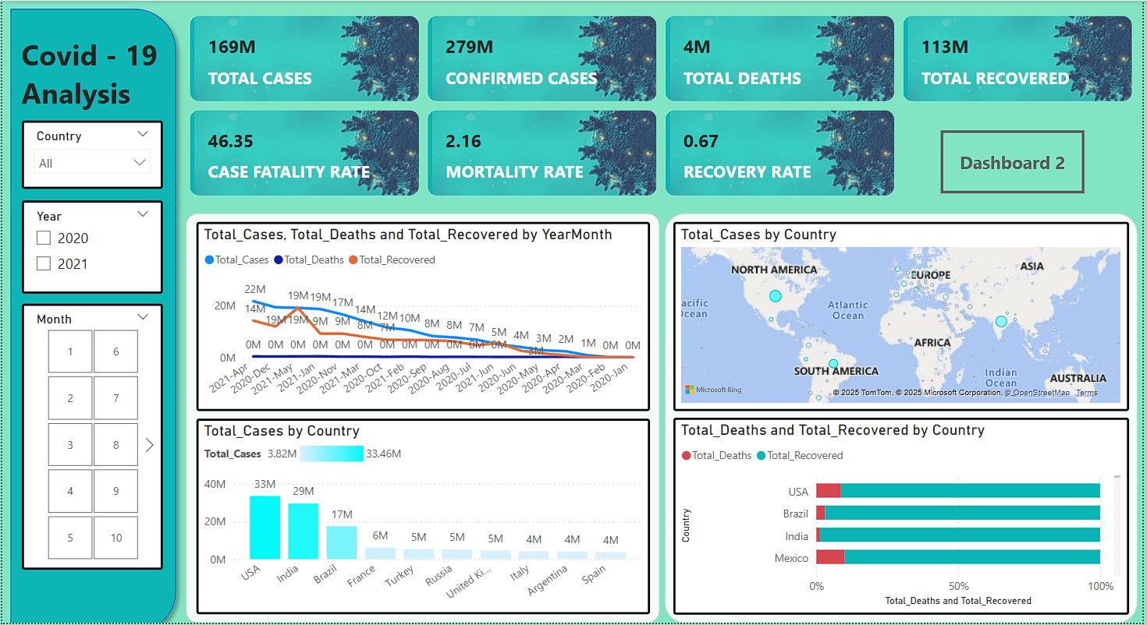

**Dashboard 1: Global COVID-19 Overview**

* Visualized infection growth over time.
* Regional comparisons for vaccination rates and fatality rates.
* Case distribution by income group and healthcare infrastructure.

**Dashboard 2: Country-Specific Insights**

* Infection rate trends by country.
* Population density and its impact on COVID-19 spread.
* Vaccination rollout efficiency by region.

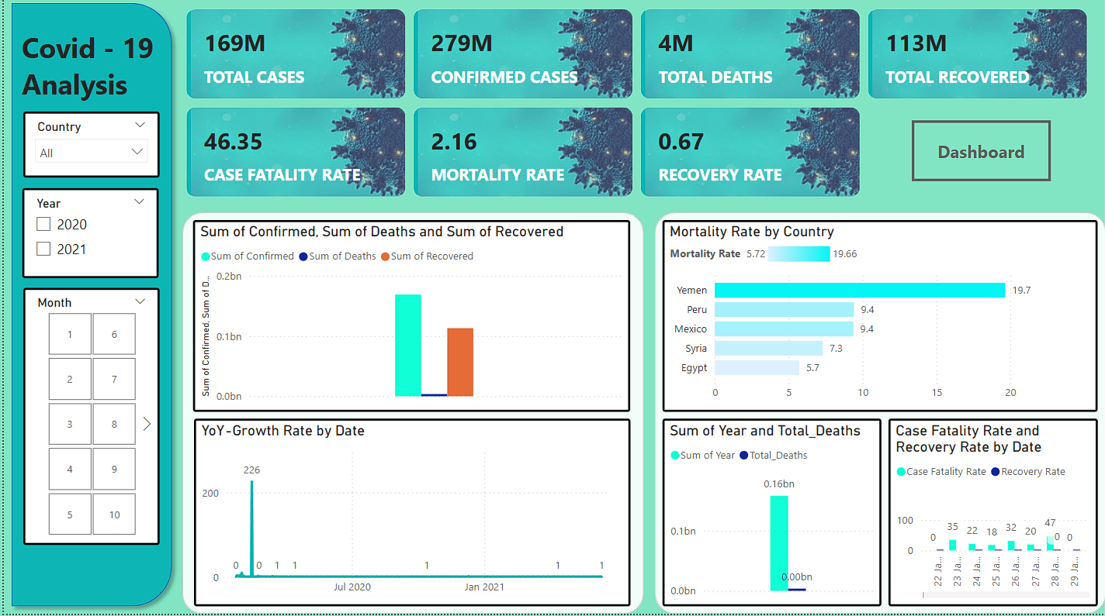

**Insights**

1. **Infection and Fatality Trends**
   * Countries with better healthcare systems showed lower fatality rates.
   * High-density regions had faster infection growth but higher vaccination rates.
2. **Vaccination Progress and Effectiveness**
   * Higher vaccination rates correlated with lower fatality rates.
   * Some regions faced slow vaccine rollouts due to infrastructure limitations.
3. **Regional Variations in Impact**
   * Developed countries managed the crisis with lower infection fatality rates due to advanced healthcare.
   * Developing countries faced higher mortality rates and slower recoveries.
4. **Healthcare System Readiness**
   * Stronger healthcare infrastructure led to faster recovery and lower mortality rates.
   * Regions with limited ICU capacity and medical supplies struggled with case surges.
5. **Economic and Social Impact**
   * Lockdowns significantly reduced infection spread but had economic repercussions.
   * Countries with digital transformation adapted better to remote work and online education.

**Recommendations**

1. **Healthcare Investments**
   * Enhance ICU and hospital capacities in vulnerable regions.
   * Improve public health communication to combat misinformation.
2. **Vaccination Campaigns**
   * Increase funding for vaccine production and distribution.
   * Improve logistical efficiency to reach remote populations.
3. **Data-Driven Decision Making**
   * Use predictive analytics to anticipate future outbreaks.
   * Develop real-time data tracking systems for government responses.
4. **Economic Recovery Plans**
   * Support businesses affected by lockdowns with financial aid.
   * Invest in digital infrastructure to enable remote work and education.

**Conclusion**

This analysis provides critical insights into the COVID-19 pandemic, highlighting key trends in infection rates, fatalities, recoveries, and vaccination progress. The findings serve as a foundation for policymakers, healthcare professionals, and researchers to make informed decisions in managing public health crises and preparing for future pandemics.